# **Final Exam: INFO-6028 “Graphics 1” Fall 2023**

Instructor: Michael Feeney

## The exam format:

* You may use any resources you feel are necessary to complete the exam, but you are to answer the questions **on your own**. I will be looking for plagiarism (i.e. copying) very carefully. There is *no possible way* that the specific code to answer these questions, or the output to the screen, would be very similar to the look of another student’s code. Remember, this is a test and there are very clear policies about cheating on tests.
* This also includes code that you’ve produced from some generative AI.
* You may also ***not*** use code that’s taken *mostly* from some existing framework (like downloading the code from the OpenGL book, Learn OpenGL, Open Scene Graph, or something like that)  
  + <http://www.fanshawec.ca/admissions/registrars-office/policies/cheating-policy>
  + <http://www.fanshawec.ca/sites/default/files/assets/Ombuds/cheating_flowchart.pdf>

How can I make the determination that it’s not “your” code? Simple: If I suspect it’s not yours then I’ll ask you to “defend” it one-on-one where I’ll ask you questions and see if you know what you’re doing or why the code is the way it is. If you have no idea what’s going on, then it’s pretty certain you didn’t write it yourself. Simple as that and also a tried and true technique. You *can* use any code *provided in class* or you wrote *this term.*

* You ***may*** use simple utility libraries like assimp, loadPNG, JSON/XML loaders, sound, etc. **No** boost, though.
* It is an “open book” exam. You have access to anything in any book, internet resource, or anything on your computer, or that has been uploaded in class, including projects you’ve already completed.
* The questions are ***NOT*** of equal weight. The exam has **nine (9)** questions and **eight (8)** pages.
* The questions build on each other so you can put them in one solution/project.  
  If you feel you need further clarification, please include a readme file (and a video if you’d like, though not required).
* ***PLEASE*** delete any temporary files that Visual Studio generates (to reduce the upload size)
* Do ***NOT*** do some clever “*oh, you just have to comment/uncomment this block of code*” nonsense. However, if the questions ***CLEARLY AND OBVIOUSLY*** build on each other, you may combine them (like if one question places objects, then the next one moves objects around with the keys) – even so, **MAKE IT 100% CLEAR** to me what questions the solution is attempting to answer. **I do NOT want to edit the code in any way.**
* For applications: if it doesn’t build and run, *it’s like you didn’t answer it*. I’ll correct trivial, obvious problems (like you clearly missed a semicolon, etc.), but you need to be sure that it compiles and/or runs.
* You have until **11:59 PM** on **Tuesday, December 12th** to submit all your files to the appropriate drop box on Fanshawe Online. **NOTE:** Although this may “look and feel” like a project, it isn’t, it’s an **exam**, so there is **no concept of “late marks**”; if you don’t submit your files the time the drop box closes, you don’t get any marks at all.

*Please don’t be late submitting and* be **SURE** that you are *actually* submitting the *correct* files.

* Unless otherwise indicated, all these solutions assume that you are creating/using a C++ project using Visual Studio 2022 using the OpenGL 4.x API (with GFLW, glad, and glm).
* I will be building using the default Visual C++ settings (C++ 14).

## The Questions:

You are to create one or more “ruined buildings” made up of the parts from the Synty Studios “POLYGON - Dungeon Realms” (<https://syntystore.com/products/polygon-dungeon-pack>) and “POLYGON - Pirate Pack” (<https://syntystore.com/products/polygon-pirate-pack>).

Many of the “environment” assets can be combined like LEGO bricks into any shape you’d like. They are all of similar size. In the picture below, you can see there’s a bunch of different “floor” models as well as a number of “wall” models.

These are in the “3D_Models” folder.

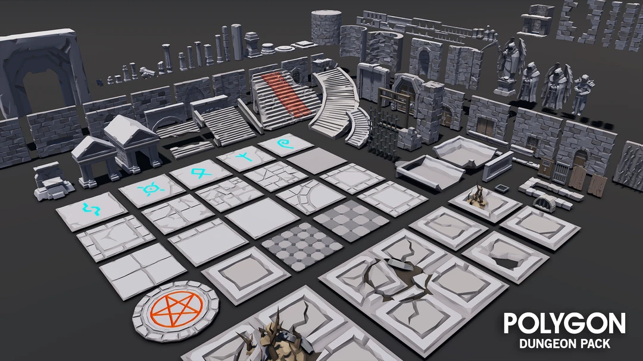

The idea is that these are *very* old building with stone walls, but there is no roof, as they were wooden and have rotted away long ago (i.e. there’s only walls, no roof anymore, so you can see the sky).

**Some notes about the models:**

* They are aligned in one corner of the model. This allows you to “snap” them together more easily (MeshLab “Render”, then “Show Axis” will show this.)
* The textures that correspond to the model are shown in the ply file, for example, the SM_Env_Floor_Grate_01.ply file has the following:  
    
   comment TextureFile Dungeons_2_Texture_01_A.png   
    
  This means that you need the Dungeons_2_Texture_01_A.png file as a texture.
* I’m pretty sure I’ve converted them all to an xyz+normal+rgba+uv format, but there’s 100s of files in there; if I haven’t, then you should be expected to convert and/or load them yourself.

You’ll be taking the layout of the building will be taken from the “One Page Dungeon” generator, located here: <https://watabou.itch.io/one-page-dungeon>

Note that some of these are quite large, so just keep refreshing the page until you get to a layout that that you’d like to make. Note that they have to be *at least* the size of these ones.

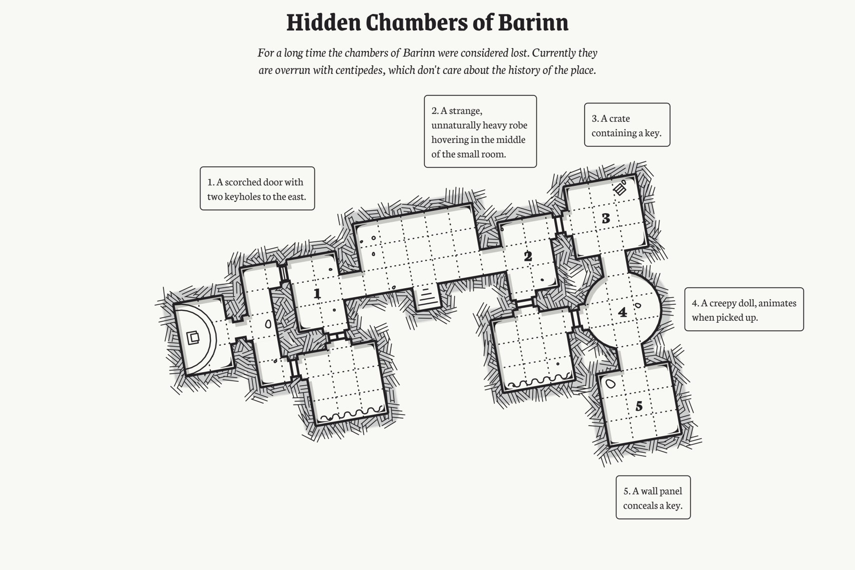 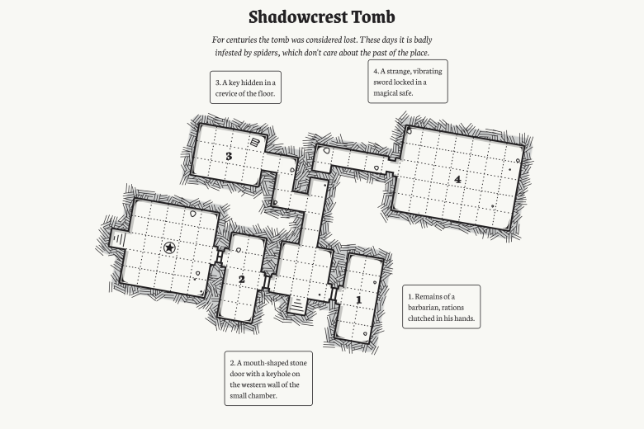

This site is supposed to generate “dungeons” so something like the map on the right (Shadowcrest Tomb) would have long, narrow corridors/hallways (inside the red circle), where the one on the left doesn’t really have these (there are a couple very short ones, I suppose...)

In Dungeons and Dragons, the squares are 5x5 feet in size. So these hallways are 5 feet wide.

(Interestingly the 3D models are in 500x500x500 unit squares – coincidence?)

My point is that since we are using these as *building* floor plans rather than underground dungeons, you have a couple options:

* They could be long narrow rooms.
* They could also be outside walkways between separate buildings.

Use your own artistic discretion with this.

A note about two people using the same dungeon: this is *very* unlikely that this will happen since they are generated randomly, but even if it did happen, there is zero chance that *what you generate in your submission* is in any way the same (or even similar) to someone else in the class.

Note: unless otherwise stated, all the models need to be appropriately textured (or coloured*). The dungeon models have various alternative textures and the beholder has both a texture as well as the vertex colours “baked” into the model.

(* they *can’t* be just one colour, though. You can use the vertex colours instead of the texture colours if you want to “bake” the colours in, but I wouldn’t recommend that – some models won’t look good.)

1. (5 marks) Pick a floor layout from the “One Page Dungeon” site.   
     
   If you right-click, you can:  
   * Save it as a PNG file.
   * Get the “permalink” so you regenerate it later.  
       
     (Here’s the one for “Shadowcrest Tomb”: <https://watabou.github.io/one-page-dungeon/?seed=1686096162>)
2. (200 marks) Using the “POLYGON Dungeon Realms” components, make floor and walls of your building.   
     
   For the “ground” use one of:  
   * the “Island” model you can get from the “Terrain to Island” converter program.
   * one of the “fractal terrain generator” models from meshlab,
   * or another model you’ve found/made.

The only requirement for the “ground” the building is on is that it’s very large – I **shouldn’t** see the “edges” of the ground model (I mean it should be *way* off in the distance, so if the camera is anywhere near the building, the “ground” model should be HUGE in comparison, like 100x bigger or something like that.)

At this point, you *don’t* need any “fancy” lighting (that’s later).

Position the camera so the entire building can be clearly seen – so that it can be compared to the floor plan you generated in question 1.

1. (100 marks) Set up the night sky using the “Space skybox texture” (This is the same texture that we used in class).
2. (100 marks) Set up “full moon night time” lighting in the following manner:
   * Place a dim light (point or directional) to illuminate the entire scene. Let’s assume it’s a “full moon” (more on this in a moment) and lights up everything a little bit.
   * Create a “full moon” using the assets in the “CGI_Moon_Kit” (the link to the NASA site where I got the textures, if you want larger ones):
     + There is a “UV Sphere” with “cylindrical UV projection” which will “wrap” the wide moon surface texture around the sphere.
     + Place the moon (the UV Sphere) object somewhere in the sky.
     + It should be bright, like a full moon, but does not necessarily need to be light with an actual light. i.e. you could use “emissive” light or shine a light on it – but the key here is that it should be evenly lit (like a full moon).
3. (300 marks) Place a number of lit “torches” in the scene:
   * Place at least five (5) lit “torches” on the walls of your building(s). These should be spread out, with no more than one torch per “room”. Use your judgement here, but I’m don’t want all the torches lumped together, so if your map has one large room (or something like that) then please spread the torches out.
   * Use one (or more) of the “torch” models in the Dungeon set. i.e. they can be all the same torch model or all different – your choice.
   * The “fire” area of the torch is set up as follows:
     + Place an “imposter” (quad or tree or whatever) with a “fire” texture on it, in the part of the torch that would have the flame.
     + Using alpha or discard transparency, block out the “non-fire” portion of the texture.
     + Place an orange/red point light at the same location of the fire imposter object. This light will cast nearby (i.e. is the “firelight” from the torch.
     + Make sure the “fire” (textured) part of the torch is bright. This can be using a light or using an “emissive” light on the fire itself.
     + Modulate the length of the “fire imposter” as well as the brightness of the light quickly over time. In other words, the light should “flicker” like a fire and the imposter should *slightly* grow and shrink approximating the length of the flame.
4. (300 marks) **THIS QUESTIONS HAS TWO OPTIONS DEPENDING ON YOUR MAP:**
   * If the map ***has*** water (like this one):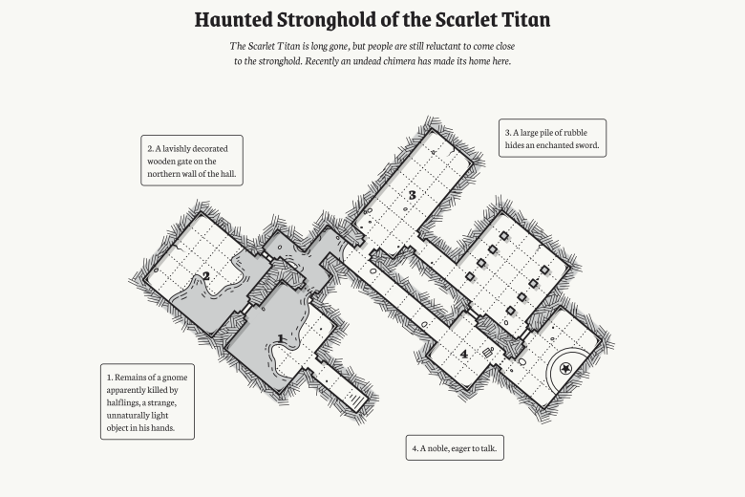
     + Mimic the surface of the water using a fractal terrain from MeshLab. Make sure the height of the terrain is very small (i.e. the height of the “waves” or “ripples” on the water would be very small, right?).
     + Make sure you recalculate the normals inside MeshLab before you export it.
     + To generate the UV coordinates, use “Filter”, “Texture”, “Parameterization: Flat Plane” and use the choice that matches the surface of the model (the mesh is aligned on the XY plane by default).
     + On the internet, find a “water surface” texture that you like.
     + Apply this water texture to the water surface, and make the water semi-transparent.
     + *Using the normals from the water surface,* sample the space cube map. This will give the effect that we see:
       - A semi-transparent water surface (so we can see something underneath)
       - A bit of the “water” texture
       - A reflection of the sky on the surface of the water, too.
   * If the map ***doesn’t***have water:
     + Place at least three (3) “crystal” models throughout your buildings.
     + Either set a single colour or choose a texture of a single colour (i.e. the colour of the crystal) for each crystal. They should be different colours.
     + Make them semi-transparent.
     + *Using the normals from the crustal surface,* sample the space cube map. This will give the effect that we see:
       - The coloured crystals are semi-transparent (i.e. we can see through them)
       - They reflect sky on their surface, too.

|  |
| --- |
| Note: If your map HAS water, but you’d rather do the crystal thing, then just ignore the water part.  i.e. *don’t* put the water in the scene. |

1. (**BONUS:** 100 marks) Do BOTH the water AND the crystals.
2. (200 marks) Add an attacking “Beholder” to your scene.

Beholders are monster characters from Dungeons and Dragons. You can read *way* more than you probably want here: <https://www.dndbeyond.com/compendium/cyclopedia/vgtm/beholders>

Here’s the part that you need to know:

* + They have lots of eyes on their stalks (like snails).
  + Each one of their eyes can shoot a different type of magical rays.
  + Beholders are sort of giant ass-holes in that they literally think they are the best thing in the universe and will attach *anything* (even other beholders).
  + We are going to adjust the size of the Beholder and assume it’s approximately 2-3 feet wide.  
    (They are normally 6 – 7 feet, but that’s too wide for the 5’ wide hallways)

The point is that they will *always* attack everything, and this one *is* attacking.

Mimic three (3) of the magical rays from three (3) of the Beholders eyes:

* + Place a very bright, but very “tight” spot light at each of the eyes.
  + This spot light will shine in some direction more or less where that eye is looking.   
    (Note: we’re talking about the little eyes on the stalks *not* the giant eye in the middle)
  + They are “tight” in that the spot cone angle is very small, like 5 degrees or something.   
    It should look like a “tight” flash light beam.
  + 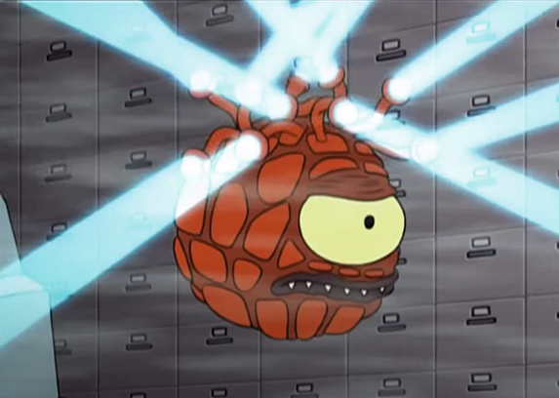Each eye ray should have a different colour and be facing a *slightly* different direction.   
    The idea is that the Beholder thinks it’s seen something, but isn’t 100% sure *exactly* where its target is, so is shooting three rays in the general direction of where it’s facing.

Here’s an idea of what I’m talking about: <https://youtu.be/_H18JLCYj0g>   
  
Note that here the “rays” are more cylindrical than cone shaped, but not that the “rays” are coming from the little eyes in the stalks.

.

1. (**BONUS:** 100 marks) Show the outline of the Beholder’s eyes by using the “beholder_vision_cone” model. Make this the same colour as the lights you are using and make it semi-transparent.

The cone lines up with the large eye of the Beholder, but you’ll need to add cones for each of the “rays” you used in question 8 (i.e. you can’t just have a single cone).

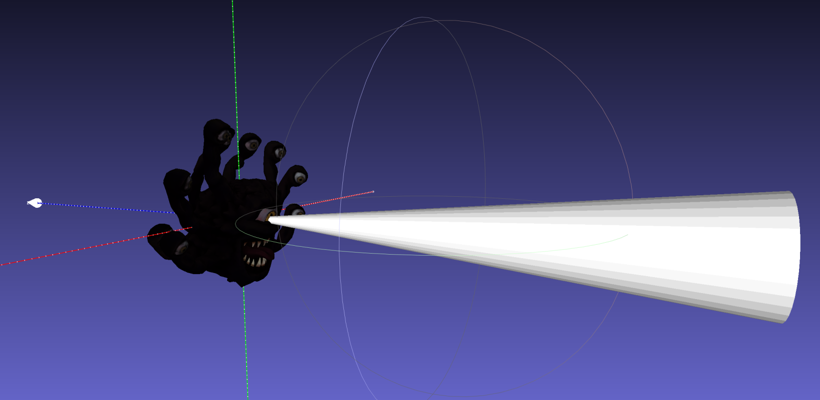

You will also have to change the “end size” of the code to reflect how “tight” you’ve chosen your spotlights in question #8. Since you don’t care about the normals here – you are just displaying this as a semi-transparent/non-lit object, you can non-uniformly scale the cone around the X and Y axes to “narrow” or “widen” the light cone.

The idea is that the large part of the code matches the size of the spot light at that point.

You will also have to “fade” the transparency of the cone over distance, just like a light would. You can do this by adjusting the transparency as it is further away from the “point” end.

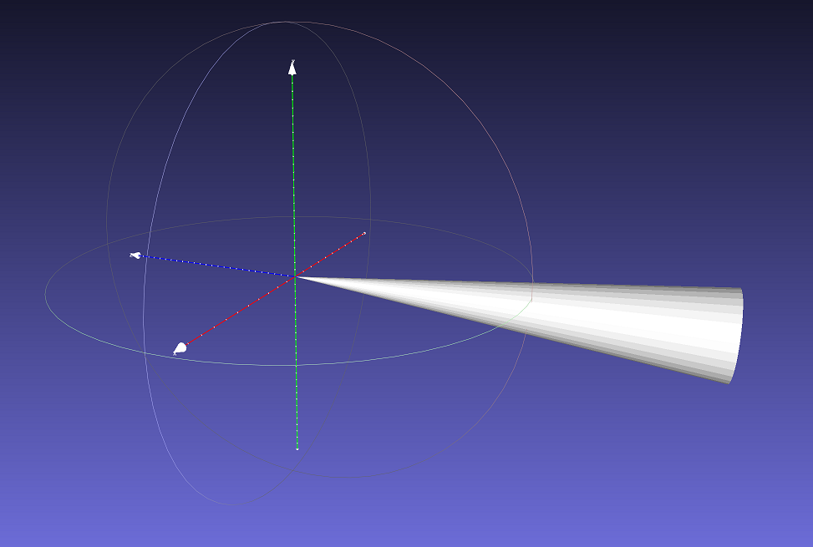

**That’s it.**